Install Instructions for part# RSJL24KIT
2018 JEEP JL Complete Quad Cube Pillar Kit - (4) 24-Watt Blacked Our Series® Cubes with Pillar Mounting bracket and wire harness.
- Begin by assembling 3x3 cubes on the brackets using supplied bolts.
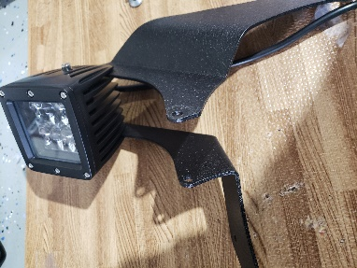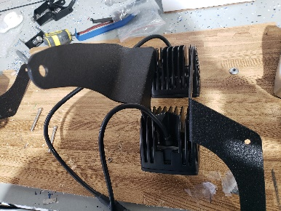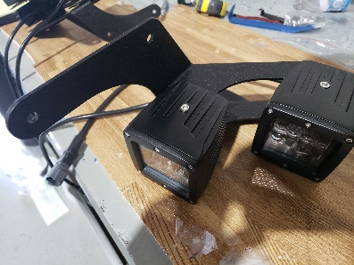
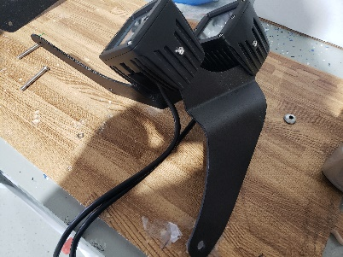
- Remove factory bolts from the vehicle. The bolt on the fender closer to the door, and the two bolts on the hood by the wiper cowl.
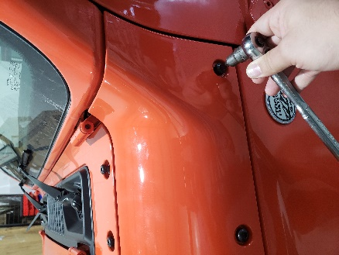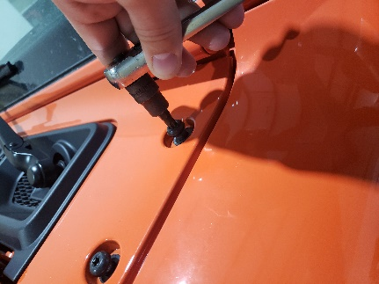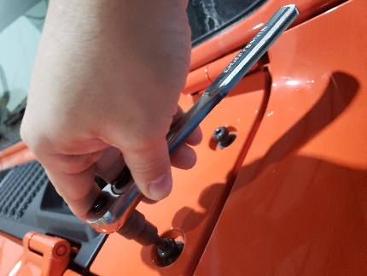

- Take assembled brackets and cubes and mount them to their respected sides using two ½ spacers on the top hood cowl and two 2” screws, and the ¼ spacers for the fender side of the vehicle. Hand tighten the bolts do not fully tighten yet.
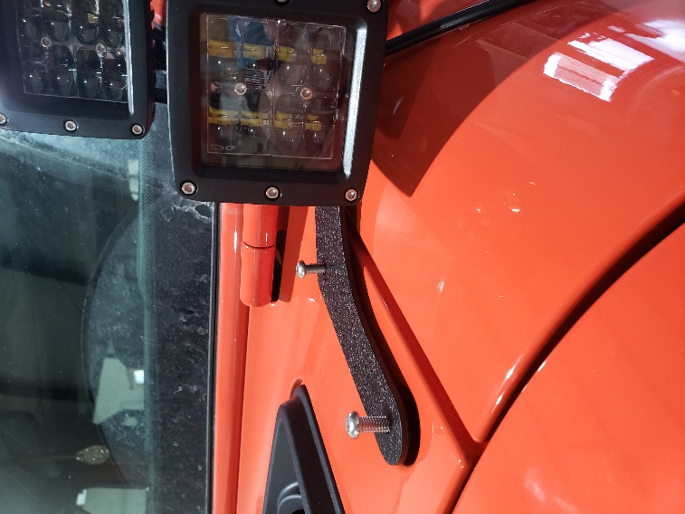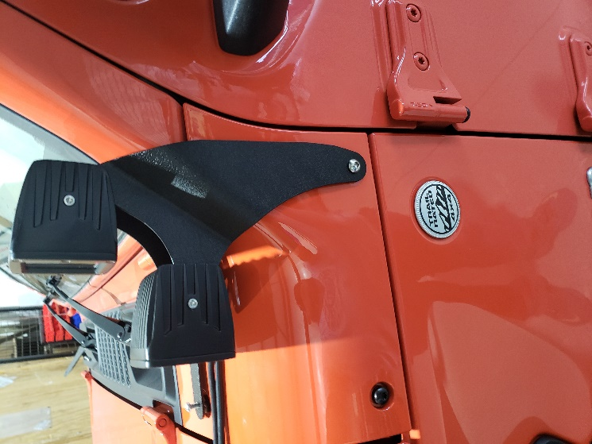
4.Run wires through the crevasse between the fender and wiper cowl. Run relay harness and switch in desired location. Now you can fully tighten all bolts to the vehicle align 3x3 cubes to desired location and make sure to tighten the cubes and bracket.

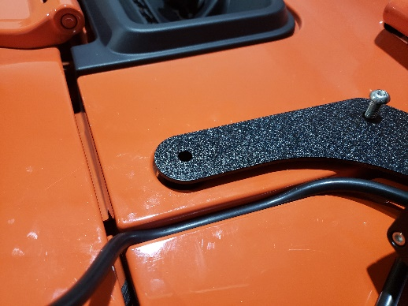

*You can combine our 50” inch stealth bar bracket to complete a great look on the Jeep Wrangler (part# RSJL50240) take a look.
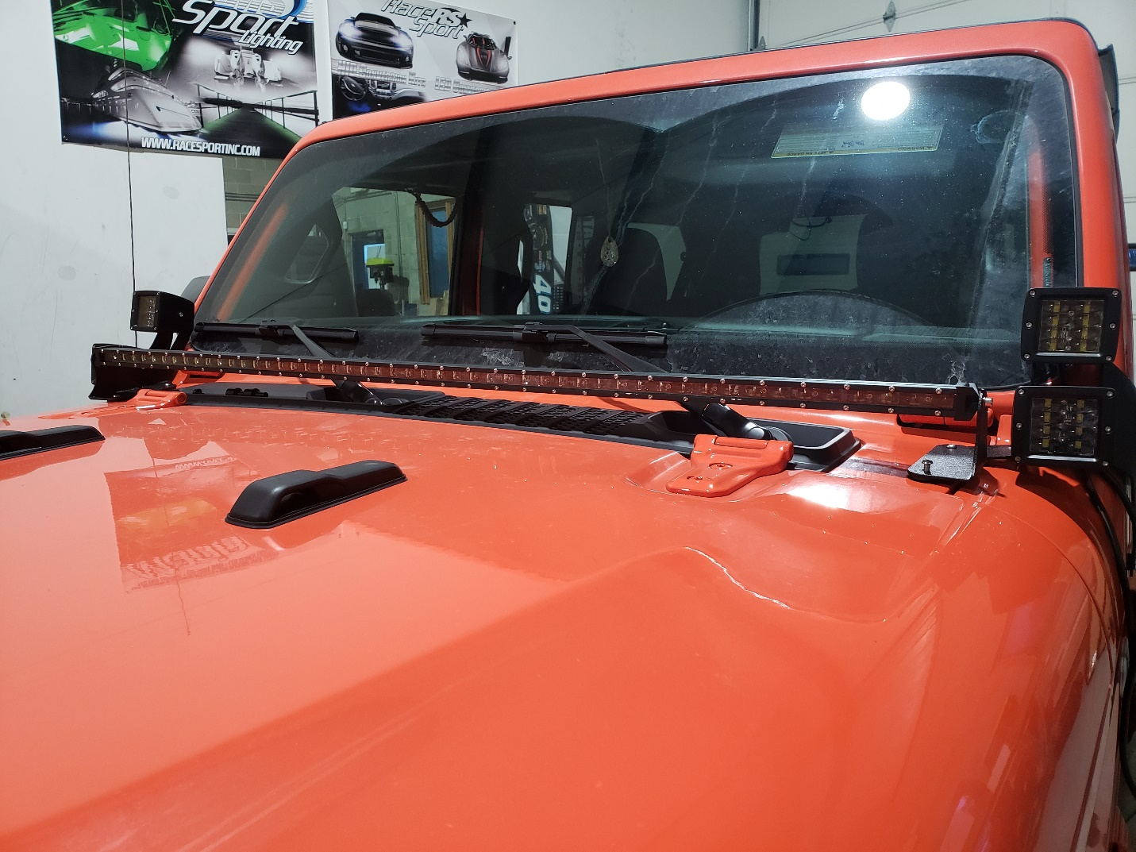

Questions feel free to contact us at 847-327-0073 extension 3 (tech support)

