RSJLPB001 2018 JEEP JL Custom Pillar Mount Bracket holds (2) or (4) cubes and auxiliary spots on Left and Right Side - Made in USA Install Instructions
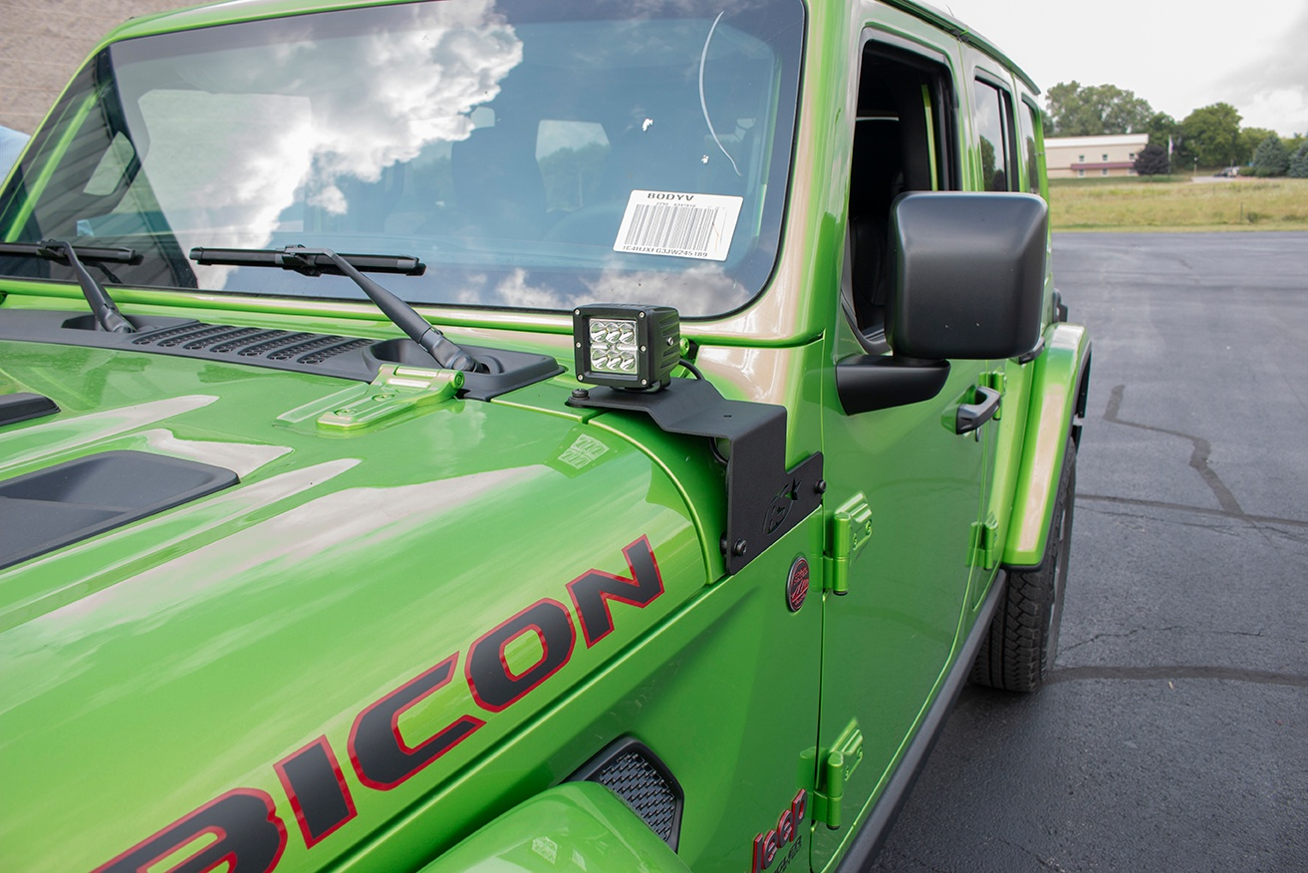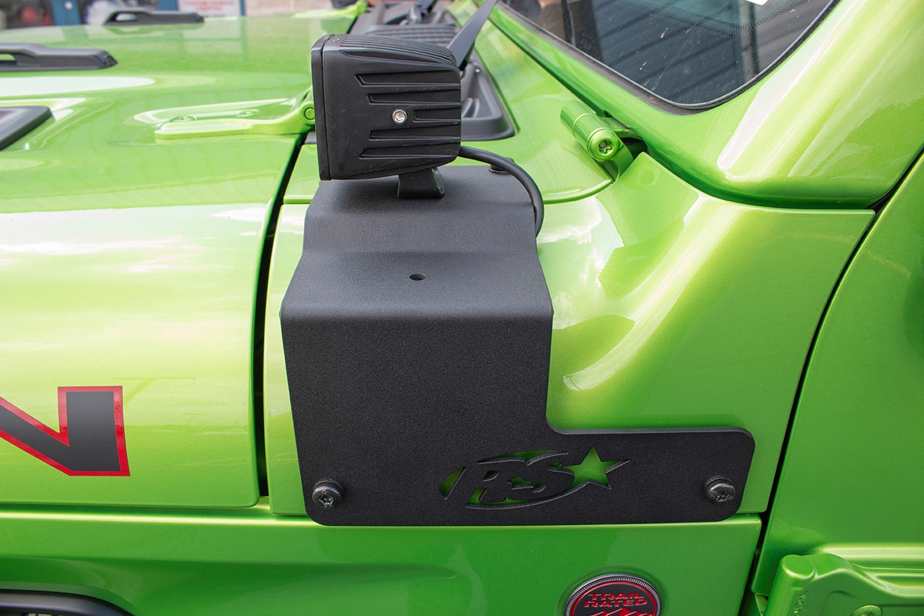
- Unscrew and remove factory hex bolts both fender side and wiper cowl bolts.
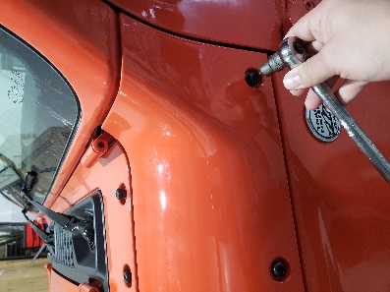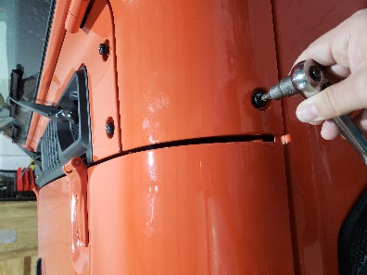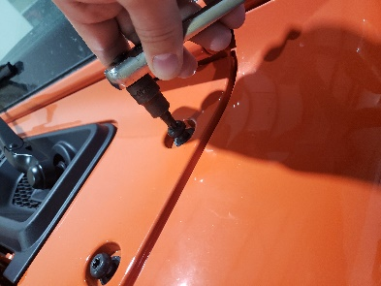

- Mount desired 3x3 cubes on existing holes on top of the brackets You may do two sets on each bracket or you can do on pair plus 52-inch light bar along with our hood mount bracket (RSJL50240).
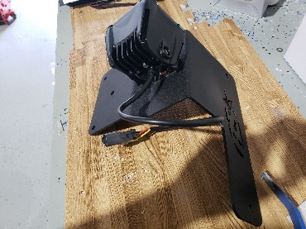
- Once the 3x3 cubes have been mounted, use supplied spacers and bolts to mount bracket to the vehicle. The longer spacers are for the two existing holes on the wiper cowl the other smaller spacers go to the fender side existing holes.
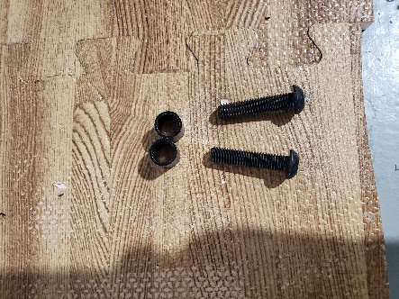Fender Side bolts and spacers.
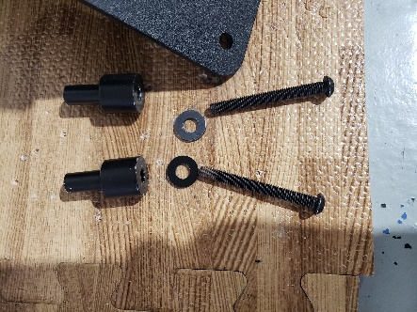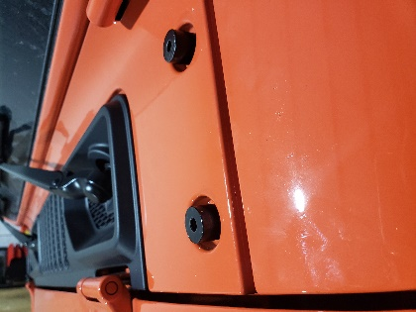 Wiper cowl spacers and bolts on the hood.

- Now you may assemble brackets to the vehicle, hand tighten only until you run the wires through the crevasse between the wiper cowl and fender side.
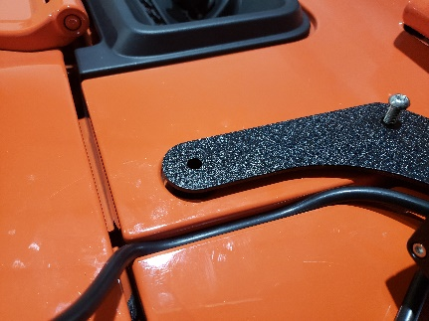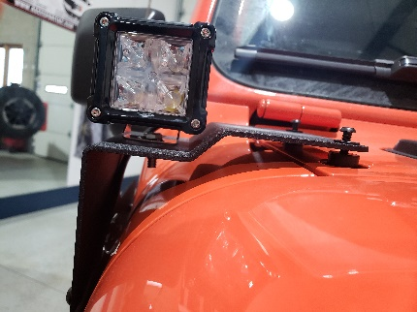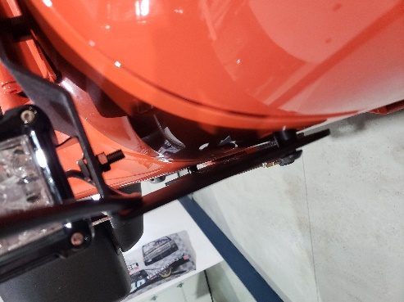
- Once you have ran the wire and relay harness, and mounted the switch in desired location, test the cubes to make sure they are functional. Now you can tighten the bolts down. As a specified earlier you can use or 52-inch light bar and bracket to finish off the great look on the jeep part # RSJL50240.

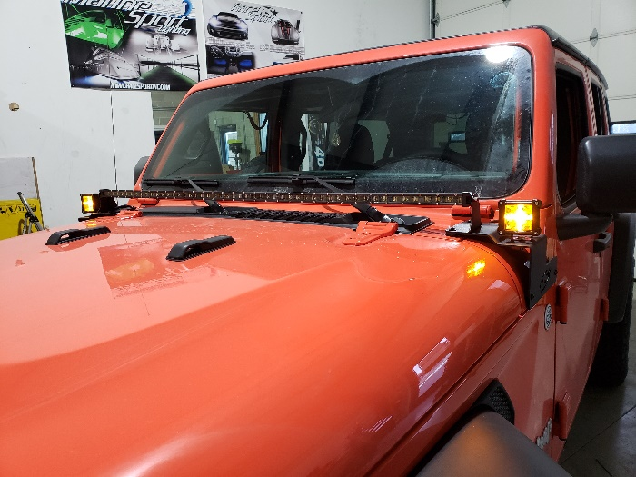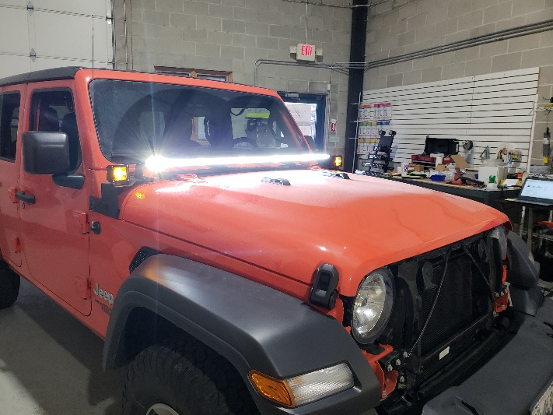
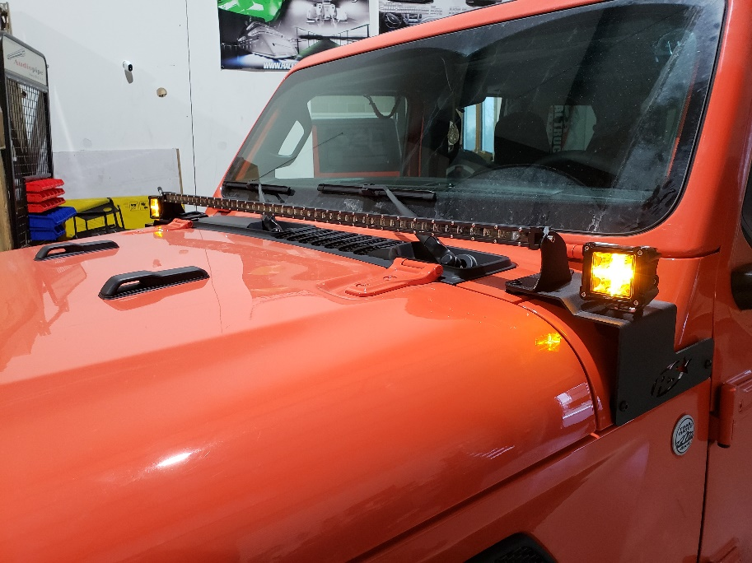
Questions please feel free to contact tech support 847-327-0073 ext. 3

